11.70:

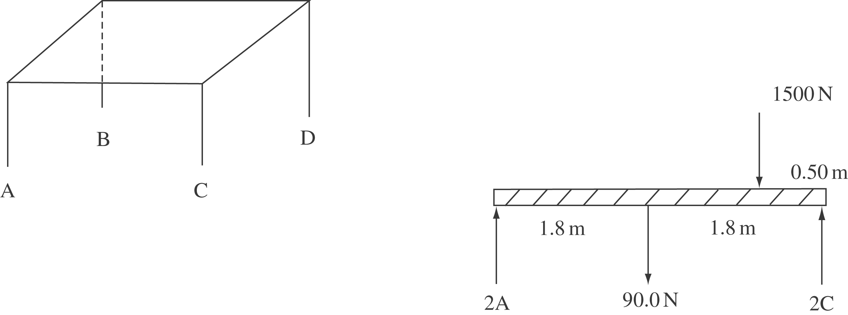

By symmetry, A=B and C=D. Redraw the table as viewed from the AC side.
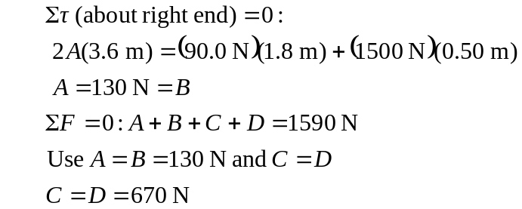
By Newton’s third law of motion, the forces A, B, C, and D on the table are the same as the forces the table exerts on the floor.

